Stage 2 – Project Requirements: Data Requirements & ERD
Date: September 24, 2025

STEP 1 – Data Requirements
- Group Number & Member Names
Group Name: DBMS_Three
Members: Rithik Rathinavel Ragupathi
Irfan Saleemudeen
Siddharth Reddy Yeddula

1.1 Company Background & Industry
Gowtham Property Developers (India) is a real-estate company in India that specializes in developing and selling residential plots. The company is currently managing three ongoing projects: Pulavar Nagar (8.63 acres), Gowtham Nagar (9.77 acres), and Vasudevan Nagar (9.54 acres). Each project consists of multiple plots that are offered to customers at prices based on the government-issued Guideline Value, which serves as the fixed selling price at the time of sale. Plots have a fixed listed price that changes over time and a government guideline value (must be paid via bank). The rest may be paid in cash. Profit from one property may be rotated (transferred) to fund another property’s expenses. The company’s operations require careful financial tracking to ensure compliance with government regulations, manage ongoing development expenses, and provide transparency to customers.

1.2 Current Problems and Scope
- Current: Paper/Excel ledgers for expenses; no versioned price history; rotation between properties not auditable; customers can’t view their plot expenses cleanly.
- Problems: Redundancy, errors, no time-based price tracking, weak traceability of rotations, poor visibility for customers.
- Scope (included): Properties, plots, customers, sales, payments (bank vs cash), per-plot expenses, price history (fixed & guideline), property ledger & money rotation, customer-facing view limited to their plot + its expenses.
- Excluded: HR/payroll, tax filings, GIS mapping, external bank integrations.

1.3 Business Operations
- Create a Property and add Plots.
- Maintain price history per plot for FIXED_PRICE and GUIDELINE_VALUE (effective date ranges).
- Record per-plot expenses (JCB, road, earthwork, solar, pipe, etc.) with a normalized ExpenseType.
- Sell a plot to a Customer; record Payments split across BANK (≥ guideline value at sale date) and CASH (remainder).
- Track Property Ledger entries (initial investment, inflows, outflows, rotations).
- Record Money Transfers (rotation) between properties.
- Provide a Customer View showing only their plot and its expenses (not company income).

1.4 Requirements
Property( PropertyID, Name, Location, Status )
- 1–N with Plot (each plot must belong to exactly one property).
Plot( PlotID, PropertyID*, PlotNo, SizeSqft, Facing, Status )
- 1–N with PlotExpense (if posting expenses per plot).
- 1–N with PriceHistory (time-varying).
- 0..1–1 with Sale (a plot sells at most once).
ExpenseType( ExpenseTypeID, TypeName, Description )
- Lookup for expense categories (JCB, Road Making, Earthwork, Solar, Pipe, Legal, etc.).
PlotExpense( PlotExpenseID, PlotID*, ExpenseTypeID*, ExpenseDate, Amount, Notes )
- ExpenseType (1) — (N) PlotExpense
PriceHistory( PriceHistoryID, PlotID*, PriceType, Amount, EffectiveFrom, EffectiveTo )
- PriceType ∈ {‘FIXED_PRICE’, ‘GUIDELINE_VALUE’}; no overlapping ranges per (PlotID, PriceType).
Customer( CustomerID, FullName, Phone, Email, Address )
Sale( SaleID, PlotID*, CustomerID*, SaleDate, AgreedPrice )
- Enforce unique PlotID to ensure 0..1 sale per plot.
Payment( PaymentID, SaleID*, Method, Amount, PaidOn, RefNo )
- Method ∈ {‘BANK’, ‘CASH’}. Business rule: ∑BANK ≥ guideline value (effective at SaleDate).
PropertyLedger( LedgerEntryID, PropertyID*, EntryDate, EntryType, Amount, Notes )
- EntryType ∈ {‘INITIAL_INVESTMENT’, ‘EXPENSE_OUTFLOW’, ‘SALES_INFLOW’, ‘ROTATION_IN’, ‘ROTATION_OUT’}.
MoneyTransfer( TransferID, FromPropertyID*, ToPropertyID*, Amount, TransferDate, Notes )
- Directional Property ↔ Property transfer (rotation). Mirror via PropertyLedger entries.

Key Relationships & Cardinalities (As we designed in our ER Diagram):
- Property (1) — (N) Plot.
- Plot (1) — (N) PlotExpense.
- ExpenseType (1) — (N) PlotExpense
- Plot (1) — (N) PriceHistory.
- Plot (1) — (0..1) Sale;
- Customer (1) — (N) Sale.
- Sale (1) — (N) Payment.
- Property (1) — (N) PropertyLedger.
- Property (1) — (N) MoneyTransfer (as From) and Property (1) — (N) MoneyTransfer (as To) i.e., This has 2 relationahips: one is the sender property and the other is the receiver property
Examples:
- “Plot 27, Pulavar Nagar: JCB ₹12,000 on 2025-08-10” → PlotExpense with ExpenseType=JCB.
- “Guideline value for Plot 27 ₹3,00,000 from 2025-07-01” → PriceHistory row (GUIDELINE_VALUE).
- “Sale S9001: BANK ₹3,00,000 + CASH ₹2,60,000” → two Payment rows (∑BANK ≥ guideline at sale date).
- “Rotate ₹5,00,000 from Property 1 to Property 2 (2025-09-20)” → MoneyTransfer + paired Ledger entries.

1.5 Sample Data ( This is just the sample data for understanding, We have given more clear schematic data in table form in step 4)
- ExpenseType: (1, ‘JCB’, ’Levelling’), (2, ‘Road Making’, ‘Gravel & Rolling’), (3, ‘Earthwork’, ’Trenching’)

- Property: (1, ‘Pulavar Nagar’, ‘Chennai’, ‘Active’), (2 ‘Gowtham Nagar’,Chennai’,’Active’), (3 ,’Vasudevan Nagar’ ,’Chennai’, ‘Planning’)

- Plot: (101, 1, 27, 1200, ‘East’, ‘Available’), (102, 1, 28, 1000, North, Sold)

- PlotExpense: (1001, 101, 1, ’2025-08-10’, 1200, ‘JCB Levelling’), (1002, 101, 2, ’2025-08-15’, 35000, ‘Road work’)

- PriceHistory: (5001, 101, ’GUIDELINE_VALUE’, 300000, ‘2025-07-01’, ‘9999-12-12-31’), (5002, 101,’FIXED_PRICE’, 550000, ‘2025-07-01’, ‘2025-09-14’)

- Customer: (‘C001’, ‘Arjun Kumar’, 9897357575, ‘arjun@gmail.com’, ‘Chennai’), (‘C002’, ‘Meera’, 8765953765, ‘meera@gmail.com’, ‘Chennai’)

- Sale: (‘S9001’, 102, ‘C001’, ‘2025-09-18’, 560000), (‘S9002’, 202, ‘C002’, ‘2025-09-22’, 600000)

- Payment: (‘P7001’, ‘S9001’, ‘Bank’, 300000, ‘2025-09-18’, ‘UTR123’), (‘P7002’, ‘S9001’, ‘Cash’, 260000, ‘2025-09-19’, ‘RCPT45’)

- PropertyLedger: (‘L8001’, 1, ‘2025-06-01’, ‘INITIAL_INVESTMENT’, 3000000,’Seed capital’), (‘L8002’, 1, ‘2025-08-15’, ‘EXPENSE_OUTFLOW’, 35000, ’Road making (plot 101)

- MoneyTransfer: (‘T6001’, 1, 2, 500000, ‘2025-09-20’, ‘Rotation to fnud allocation’), (‘T6002’, 2, 3, 200000, ‘2025-09-24’, ‘Advance for layout work’)

STEP 2 – ER Diagram
Relationship names:
- Property has Plot
- Plot incurs PlotExpense
- ExpenseType categorizes PlotExpense
- Plot has PriceHistory
- Plot sold_to Customer (via Sale)
- Sale has Payment
- Property posts PropertyLedger
- Property rotates_to(From,To) Property (via MoneyTransfer)

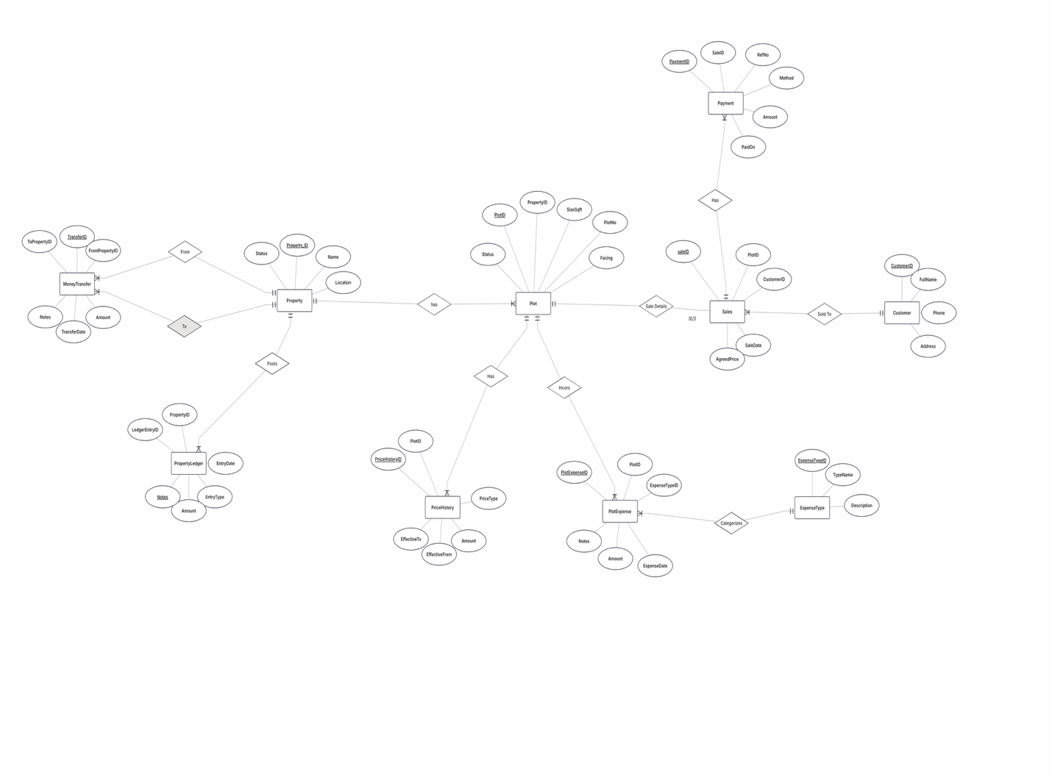

STEP 3 – Relational Data Model Conversion

a) Entities → Tables (Primary Keys are underlined for each entity, * refers to Foreign Key)
- Property(PropertyID , Name, Location, Status)
- Plot(PlotID , PropertyID*, PlotNo, SizeSqft, Facing, Status)
- ExpenseType(ExpenseTypeID , TypeName, Description)
- PlotExpense(PlotExpenseID , PlotID*, ExpenseTypeID*, ExpenseDate, Amount, Notes)
- PriceHistory(PriceHistoryID , PlotID*, PriceType, Amount, EffectiveFrom, EffectiveTo)
- Customer(CustomerID , FullName, Phone, Email, Address)
- Sale(SaleID , PlotID*, CustomerID*, SaleDate, AgreedPrice)
- Payment(PaymentID , SaleID*, Method, Amount, PaidOn, RefNo)
- PropertyLedger(LedgerEntryID , PropertyID*, EntryDate, EntryType, Amount, Notes)
- MoneyTransfer(TransferID , FromPropertyID*, ToPropertyID*, Amount, TransferDate, Notes)

(b) Relationships → FKs
- Plot.PropertyID FK→Property (1–N).
- PlotExpense.PlotID FK→Plot (1–N).
- PlotExpense.ExpenseTypeID FK→ExpenseType (1–N)
- PriceHistory.PlotID FK→Plot (1–N) with (PlotID, PriceType, date range).
- Sale.PlotID FK→Plot with UNIQUE to enforce 0..1 sale per plot;
- Sale.CustomerID FK→Customer.
- Payment.SaleID FK→Sale (1–N).
- PropertyLedger.PropertyID FK→Property (1–N).
- MoneyTransfer.FromPropertyID FK→Property; MoneyTransfer.ToPropertyID FK→Property (directional self-relationship for From and To).

(c) Final Conversion (PK/FK Notation)

1) Property
- Property(PropertyID PK, Name, Location, Status)

2) Plot
- Plot(PlotID PK, PropertyID FK → Property(PropertyID), PlotNo, SizeSqft, Facing, Status,
[UQ(PropertyID, PlotNo)] – each plot number unique within a property)

3) ExpenseType (Lookup)
- ExpenseType(ExpenseTypeID PK, TypeName, Description)

4) PlotExpense (transaction)
- PlotExpense(PlotExpenseID PK, PlotID FK → Plot(PlotID), ExpenseTypeID FK → ExpenseType(ExpenseTypeID), ExpenseDate, Amount, Notes)

5) PriceHistory (slowly changing price per plot)
- PriceHistory(PriceHistoryID PK, PlotID FK → Plot(PlotID), PriceType, Amount, EffectiveFrom, EffectiveTo,
[CK PriceType IN ('GUIDELINE_VALUE','FIXED_PRICE')],
[UQ(PlotID, PriceType, EffectiveFrom)] – avoids overlapping versions for same plot+type)

6) Customer
- Customer(CustomerID PK, FullName, Phone, Email, Address)

7) Sale
- Sale(SaleID PK, PlotID FK → Plot(PlotID), CustomerID FK → Customer(CustomerID), SaleDate, AgreedPrice,
[UQ(PlotID)] – enforces one sale per plot

8) Payment
- Payment(PaymentID PK, SaleID FK → Sale(SaleID), Method, Amount, PaidOn, RefNo,
[CK Method IN ('BANK','CASH','ONLINE')])

9) PropertyLedger (high-level accounting per property)
- PropertyLedger(LedgerEntryID PK, PropertyID FK → Property(PropertyID), EntryDate, EntryType, Amount, Notes,
[CK EntryType IN ('INITIAL_INVESTMENT','EXPENSE_OUTFLOW','SALES_INFLOW','ROTATION_OUT','ROTATION_IN')])

10) MoneyTransfer (recursive relationship on Property)
- MoneyTransfer(TransferID PK, FromPropertyID FK → Property(PropertyID), ToPropertyID FK → Property(PropertyID),
Amount, TransferDate, Notes,
[CK FromPropertyID <> ToPropertyID])

(d) Normal Forms
- All entities are in 1NF: every attribute is atomic (no repeating or multivalued attributes).
- Entities with composite primary keys (e.g., PlotExpense, PriceHistory, MoneyTransfer) have all attributes fully dependent on the whole PK → 2NF satisfied.
- There are no transitive dependencies (non-key attributes depending on other non-key attributes). For example: Publisher_Name (if included in Book table) was moved out earlier → 3NF satisfied.
- Since all determinants are candidate keys (no attribute functionally determines another except through keys), the schema is effectively in BCNF.

(e) Final Normalized Tables
- Property(PropertyID PK, Name, Location, Status)
- Plot(PlotID PK, PropertyID FK→Property(PropertyID), PlotNo, SizeSqft, Facing, Status)
- ExpenseType(ExpenseTypeID PK, TypeName, Description)
- Plot Expense(PlotExpenseID PK, PlotID FK→Plot(PlotID), ExpenseTypeID FK→ExpenseType(ExpenseTypeID), ExpenseDate, Amount, Notes)
- PriceHistory(PriceHistoryID PK, PlotID FK→Plot(PlotID), PriceType, Amount, EffectiveFrom, EffectiveTo)
- Customer(CustomerID PK, FullName, Phone, Email, Address)
- Sale(SaleID PK, PlotID FK→Plot(PlotID), CustomerID FK→Customer(CustomerID), SaleDate, AgreedPrice)
- Payment(PaymentID PK, SaleID FK→Sale(SaleID), Method, Amount, PaidOn, RefNo)
- PropertyLedger(LedgerEntryID PK, PropertyID FK→Property(PropertyID), EntryDate, EntryType, Amount, Notes)
- MoneyTransfer(TransferID PK, FromPropertyID FK→Property(PropertyID), ToPropertyID FK→Property(PropertyID), Amount, TransferDate, Notes)

(f) Minimum number of foreign keys = N–1 for N tables.
The final schema has 10 tables and 10 foreign keys, which satisfies the minimum N–1 rule. All tables are connected either directly or indirectly through relationships, so there are no isolated entities. So, according to minimum foreign key rule, Our schema has 10 > 10-1 foreign keys.

STEP 4 – Final Tables with Data
Property
PropertyID | Name | Location | Status
1 | Pulavar Nagar | Chennai | Active
2 | Gowtham Nagar | Chennai | Active
3 | Vasudevan Nagar | Chennai | Planning

Plot
PlotID | PropertyID | PlotNo | SizeSqft | Facing | Status
101 | 1 | 27 | 1200 | East | Available
102 | 1 | 28 | 1000 | North | Sold
103 | 2 | 5 | 1500 | West | Available

ExpenseType
ExpenseTypeID | TypeName | Description
1 | JCB | Excavation
2 | Road Making | Gravel
3 | Earthwork | Trenching

PlotExpense
PlotExpenseID | PlotID | ExpenseTypeID | ExpenseDate | Amount | Notes
1001 | 101 | 1 | 2025-08-10 | 12000 | JCB Levelling
1002 | 101 | 2 | 2025-08-15 | 35000 | Road Work
1003 | 102 | 3 | 2025-09-01 | 8000 | Trenching

PriceHistory (PriceType: FIXED_PRICE / GUIDELINE_VALUE)
PriceHistoryID | PlotID | PriceType | Amount | EffectiveFrom | EffectiveTo
5001 | 101 | GUIDELINE_VALUE | 300000 | 2025-07-01 | 9999-12-31
5002 | 101 | FIXED_PRICE | 550000 | 2025-07-01 | 2025-09-14
5003 | 101 | FIXED_PRICE | 580000 | 2025-09-15 | 9999-12-31

Customer
CustomerID | FullName | Phone | Email | Address
C001 | Arjun | 9876543212 | arjun@gmail.com | Chennai
C002 | Meera | 9765297638 | meera@gmail.com | Bangalore
C003 | Rithik | 8637451937 | rrr@gmail.com | Chennai

Sale
SaleID | PlotID | CustomerID | SaleDate | AgreedPrice
S9001 | 102 | C001 | 2025-09-18 | 560000
S9002 | 102 | C002 | 2025-08-16 | 430000
S9003 | 101 | C001 | 2025-09-15 | 650000

Payment
PaymentID | SaleID | Method | Amount | PaidOn | RefNo
P7001 | S9001 | BANK | 300000 | 2025-09-18 | UTR123
P7002 | S9001 | CASH | 260000 | 2025-09-19 | RCPT45
P7003 | S9002 | CASH | 320000 | 2025-08-15 | RTEP234

PropertyLedger
LedgerEntryID | propertyID | EntryDate | EntryType | Amount | Notes
L8001 | 1 | 2025-06-01 | INITIAL_INVESTMENT | 3000000 | capital
L8002 | 1 | 2025-08-15 | EXPENSE_OUTFLOW | 35000 | Concrete
L8003 | 1 | 2025-09-18 | SALES_INFLOW | 560000 | Plot sale

MoneyTransfer
TransferID | FromPropertyID | ToPropertyID | Amount | TransferDate | Notes
T6001 | 1 | 2 | 500000 | 2025-09-20 | Rotation
T6002 | 2 | 1 | 100000 | 2025-09-13 | Rotation
T6003 | 1 | 3 | 150000 | 2025-08-15 | Investment

